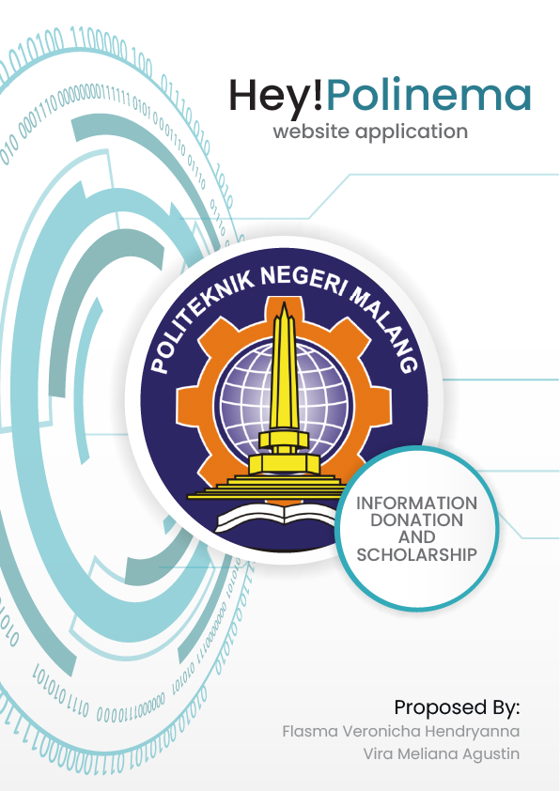COVER

# **OFFERING LETTER**

|  |  |  |
| --- | --- | --- |
| Dear State Polytechnic of Malang,  Hey!Polinema is a website-based information system that is used for students and Alumni of the State Polytechnic of Malang to be able to exchange ideas and communicate with each other by sharing information about experiences, news, events, media, until fund raiser and e-journal that may benefit each other. In addition, Hey!Polinema can be a place to strengthen the relationship between lecturers, students, and alumni of the State Polytechnic of Malang  Through this offer letter, we offer a website application design proposal for the company/institution that you are leading. The website design proposals that we offer have been attached together with this letter.  Thank you for your attention and cooperation. | | |
|  |  | Malang, 6 September 2021 |

# 

# **TABLE OF CONTENTS**

**OFFERING LETTER** i

**TABLE OF CONTENTS** ii

**LIST OF TABLES** iii

**LIST OF FIGURES** iv

**A.** **OVERVIEW** 1

**C.** **INTRODUCTION** 3

**E.** **PURPOSE AND ADVANTAGE** 4

**F.** **PROJECT / SYSTEM COVERAGE OFFERED** 5

**G.** **TIMETABLE** 6

**H.** **STAFFING AND PROJECT ORGANIZATION** 6

**I.** **BUDGET** 8

**K.** **ATTACHMENT** 9

# **LIST OF TABLES**

Table 1. Project Outlines 1

Table 2. Purpose and Advantage 4

Table 3. System Coverage Offered 5

Table 4. Staffing and Project Organization 6

# **LIST OF FIGURES**

Figure 1. WBS Hey!Polinema 5

Figure 2. Timetable Hey!Polinema 6

Figure 3. Buudget Draft Labor, Development, and Review Consulting 8

Figure 4. Server Hosting 8

Figure 5. CV Flasma Veronicha Hendryanna 9

Figure 6. CV Vira Meliana Agustin 11

# **OVERVIEW**

Table 1. Project Outlines

|  |  |  |
| --- | --- | --- |
| **Project Outline** | | |
| **Title** | Content | |
| **Project Details** | Project Name | Hey!Polinema |
| Start Date | 13 September 2021 |
| Completion Date | 22 Desember 2021 |
| Project Manager | Flasma Veronicha Hendryanna |
| **Project Description** | So many students are difficult to get information like jobs, scholarship, until journal reference. My team as Polinema student also very rarely interact with alumni except in campus organization.  Hey!Polinema is a Website-based information system that is used for students and Alumni of the State Polytechnic of Malang to be able to exchange ideas and communicate with each other by sharing contents like photos/videos, scholarship information, jobs, events or news, fund raiser, until e-journal which may benefit each other.  In addition, Hey!Polinema can be a place to strengthen the relationship between students and alumni of the State Polytechnic of Malang. This platform also can help all Polinema Family to get more information. | |

|  |  |  |  |
| --- | --- | --- | --- |
| **Project Objectives** | This website can help students and alumni to share their experience. Another benefit is we also can help other if they need help donation.  Hey!Polinema also easy to access for admin and users, which is the users only for students and alumnus. | | |
| **Project Cost** | **Budget overall requirements** | **Rp** | **73,395,000.00** |
|  | Includes: Labor, Development, and Review Consulting | Rp | 73,120,000.00 |
|  | Server Hosting | Rp | 275,000.00 |
| **Projected Return** | This project giving benefits to reduce the cost to meeting with other users offline or directly. | | |

# **INTRODUCTION**

Building a relationship must start as soon as possible since going to college. Having a good relationship can help students to get a lot of information for the next step in the future. Sadly, after students graduate, they very rarely get in touch with their juniors to share their experience.

This problem is caused by busyness of work or study. State Polytechnic of Malang’s students also come from many locations in Indonesia, which means they are inseparable with distance. The one and only way to communicate is using the Internet and Technology.

65% of Polinema students claim that if they have difficulty contacting their alumni, they don't even know them. In fact, building good communication and relationships can help them if they have difficulty. They can ask for donations or help from others, such as Polinema’s family.

Hey!Polinema is a website-based information system that is used for students and Alumni of the State Polytechnic of Malang to be able to exchange ideas and communicate with each other by sharing information about experiences, news, events, media, until fund raiser and e-journal that may benefit each other. In addition, Hey!Polinema can be a place to strengthen the relationship between lecturers, students, and alumni of the State Polytechnic of Malang.

Hey!Polinema can bridge the communication between alumni of all generations and students without having distance problems. Also, can access anytime and anywhere on their free hours.

# **PURPOSE AND ADVANTAGE**

Table 2. Purpose and Advantage

|  |  |  |
| --- | --- | --- |
| Problem | Formulation of the Problem | Goals |
| Lack of communication between alumni and students | How to bridge communication between alumni and students? | Designing social media with students and alumni as the users. |
| Difficulty in finding alumni’s career information | How to facilitate students and alumni profile? | Provide a profile feature complete with alumni’s LinkedIn. |
| Lack of information facilities regarding fund raiser | How to build fund raiser facilities for Polinema? | Provide a feature to send donation. |
| Student is difficult to search alumni’s research journal | How to get information about alumni’s research journal? | Provide a feature to share alumni’s thesis journal and rating. |
| There no information about news and events for students with alumni | How to get and set an event and news? | Designing an online calendar with events. |
| Lack of facilities to get to know each other as Polinema’s Family | How to facilitate a platform to sharing experience? | Provide post media feature which can share any media like images with caption. |
| Difficulty in finding alumni contact person to get in touch | How to facilitate a platform to exchange personal message without searching contact number? | Provide messages feature. |

# **PROJECT / SYSTEM COVERAGE OFFERED**

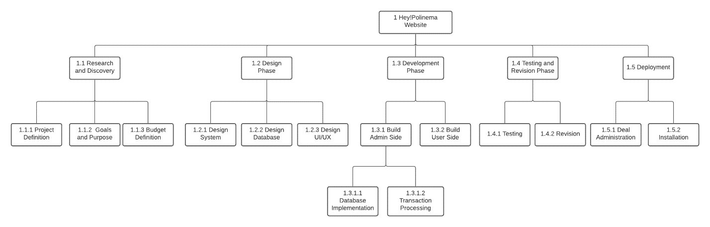

Figure 1. WBS Hey!Polinema

Table 3. System Coverage Offered

|  |  |
| --- | --- |
| Project Objectives | * Develop website-based application to bridge communication between alumni and students of State Polytechnic of Malang which provide many features such as sharing media, event calendar, news, e-journal, scholarship and fund raiser information. The cost of this project is about Rp73,395,000.00 |
| Deliverables  Outputs on every project progress included: | * Hey!Polinema social media website for admin and users which require internet connection to access. * Documentation document for Polinema’s students and alumni. |
| Milestone | * Create design for admin and user side based on system requirements. * Get all data of students and alumni from academic for profile requirements. * Import students and alumni data to database. * Website testing. |
| Technical Requirements | * Internet connection. * Provide domain and hosting as server with unlimited bandwidth, database, and SSD Diskspace also 135.000 visitor every month. |
| Limit and Exclusion | * Work done on weekdays at 8am – 4pm. * Team provide free website maintenance for 2 months. |
| Review with Customer | * Project Manager and client make a deal of this project after system requirements specification present. |

# **TIMETABLE**

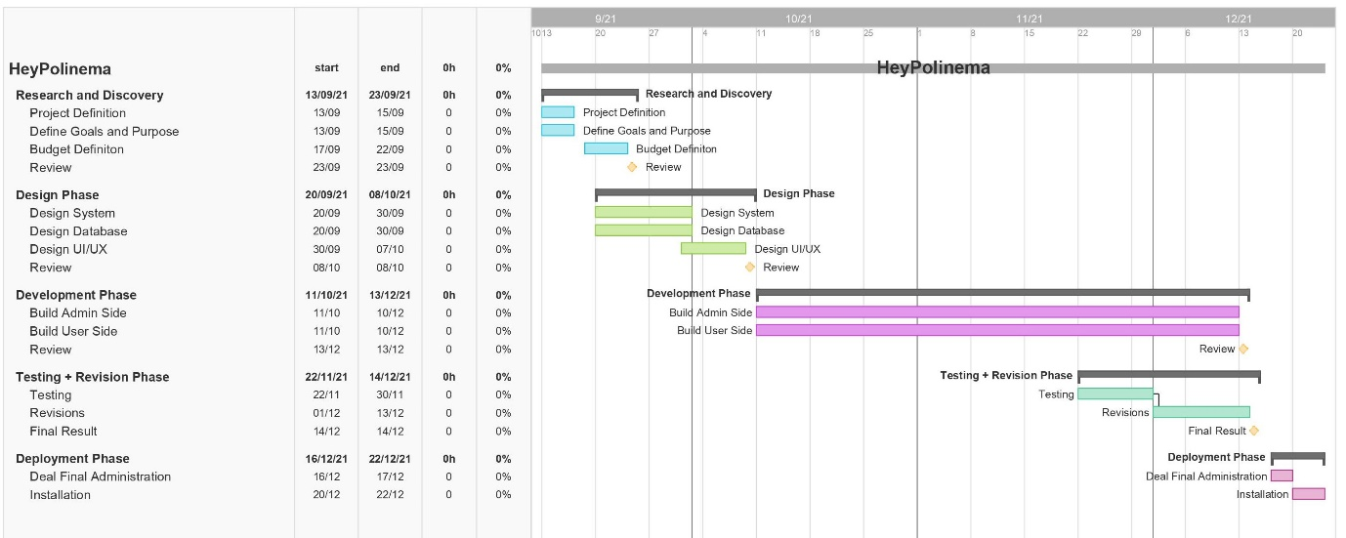

Figure 2. Timetable Hey!Polinema

# **STAFFING AND PROJECT ORGANIZATION**

Table 4. Staffing and Project Organization

|  |  |  |  |
| --- | --- | --- | --- |
|  | **Project Manager** | | |
|  | Name | : | Flasma Veronicha Hendryanna |
|  | Contact | : | veronichaflasma@gmail.com |
|  | Responsibility | : | * Planning and overseeing projects within an organisation, from the initial ideation through to completion. * Coordinate people and processes to deliver projects on time, within budget and with the desired outcomes aligned to objectives. |
|  | **Database Designer** | | |
|  | Name | : | Vira Meliana Agustin |
|  | Contact | : | virameliana@gmail.com |
|  | Responsibility | : | * Defining the detailed database design, including tables, indexes, views, constraints, triggers, stored procedures, and other database-specific constructs needed to store, retrieve, and delete persistent objects. |
|  | **Programmer 1** | | |
|  | Name | : | Vira Meliana Agustin |
|  | Contact | : | virameliana@gmail.com |
|  | Responsibility | : | * Produce functional as well as efficient programs by clean and testable coding. Integrate back-end data so as to create efficient web programs/applications. |
|  | **Programmer 2** | | |
|  | Name | : | Steave Michael |
|  | Contact | : | steavem@gmail.com |
|  | Responsibility | : | * Produce functional as well as efficient programs by clean and testable coding. Integrate back-end data so as to create efficient web programs/applications. |
|  | **Software Architecture** | | |
|  | Name | : | Hassan Marijan |
|  | Contact | : | hassanmarijan@gmail.com |
|  | Responsibility | : | * Charge of using computer code to design and develop software applications * Planning the different features of a program and integrating them into a functioning system. |
|  | **QA Engineer** | | |
|  | Name | : | Fadil Jaidi |
|  | Contact | : | fadilj@gmail.com |
|  | Responsibility | : | * Quality Control specialists * Analyze the test results and find mistakes. * Identifying and eliminating defects in a product (or, in other words, these engineers make sure that developers get the results they expect). |
|  | **UI/UX Designer** | | |
|  | Name | : | Flasma Veronicha Hendryanna |
|  | Contact | : | veronichaflasma@gmail.com |
|  | Responsibility | : | * Creating user-centered designs by understanding business requirements, and user feedback. * Creating user flows, wireframes, prototypes and mockups. * Translating requirements into style guides, design systems, design patterns and attractive user interfaces. |

# **BUDGET**

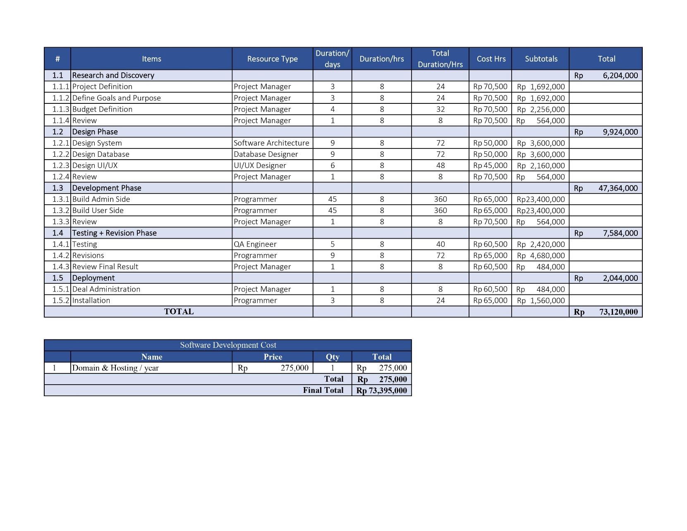

Figure 3. Buudget Draft Labor, Development, and Review Consulting

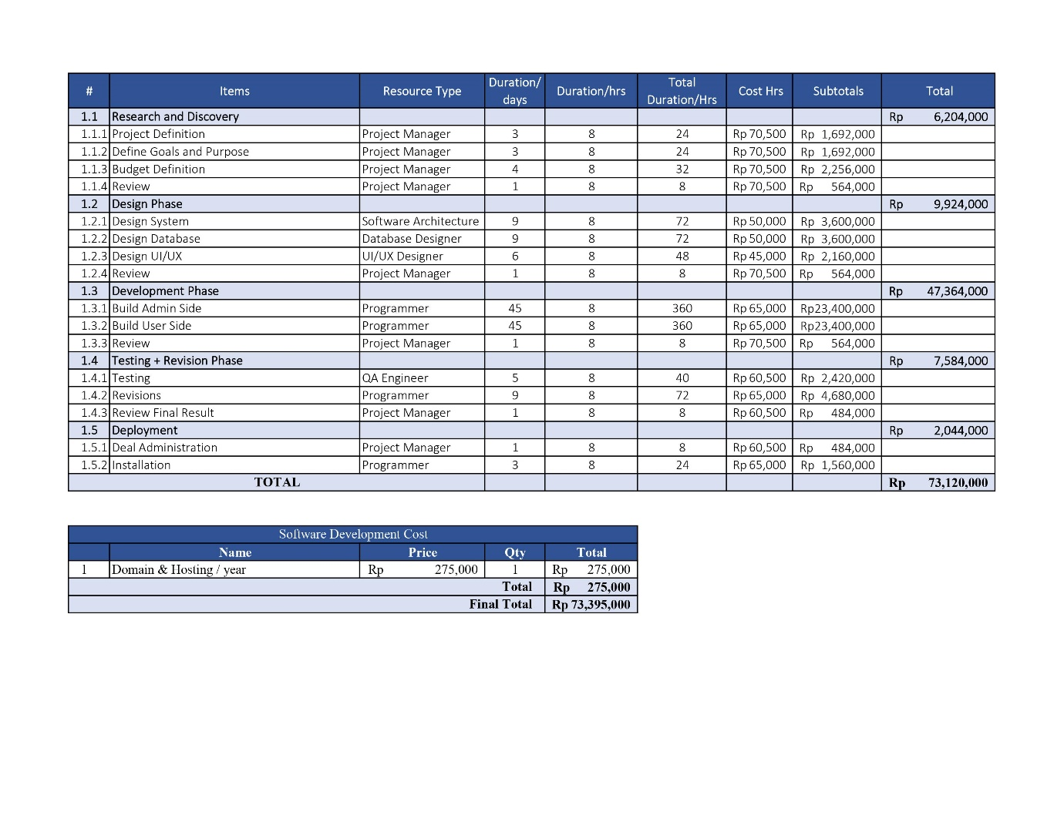

Figure 4. Server Hosting

# **ATTACHMENT**

1. **CV Flasma Veronicha Hendryanna**

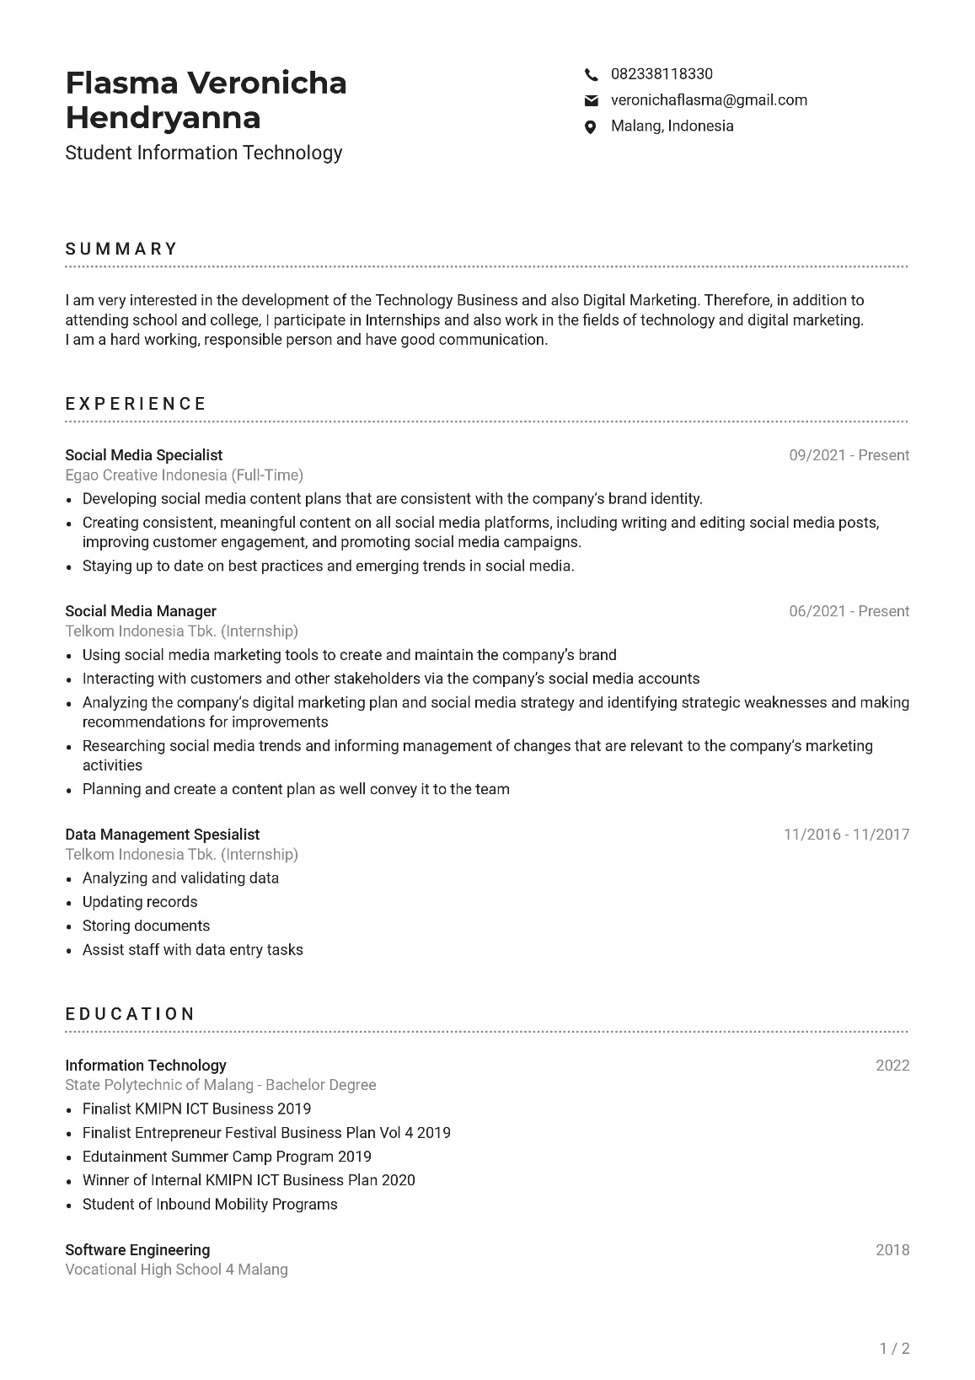

Figure 5. CV Flasma Veronicha Hendryanna

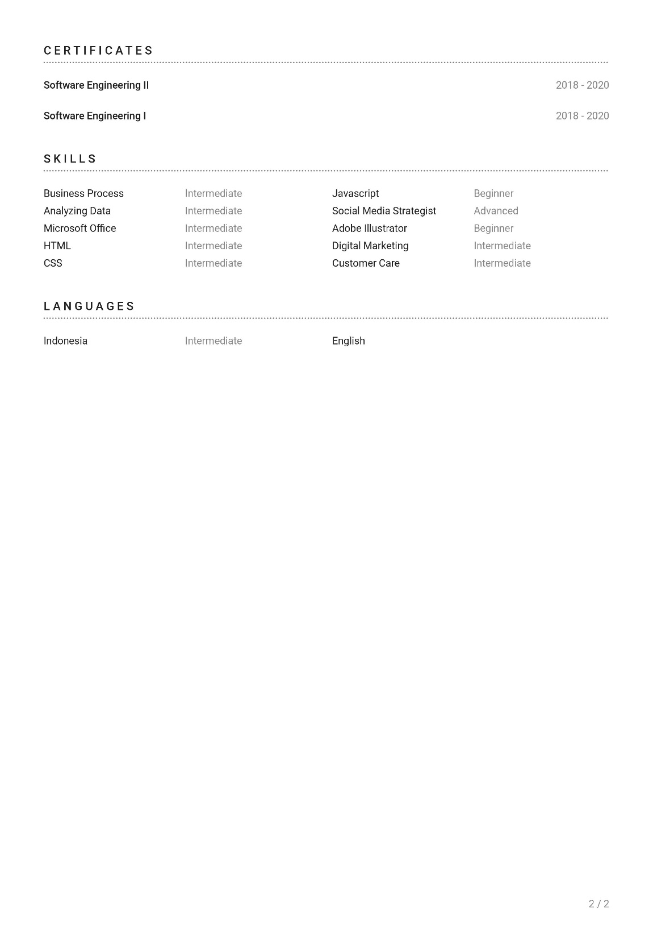

1. **CV Vira Meliana Agustin**

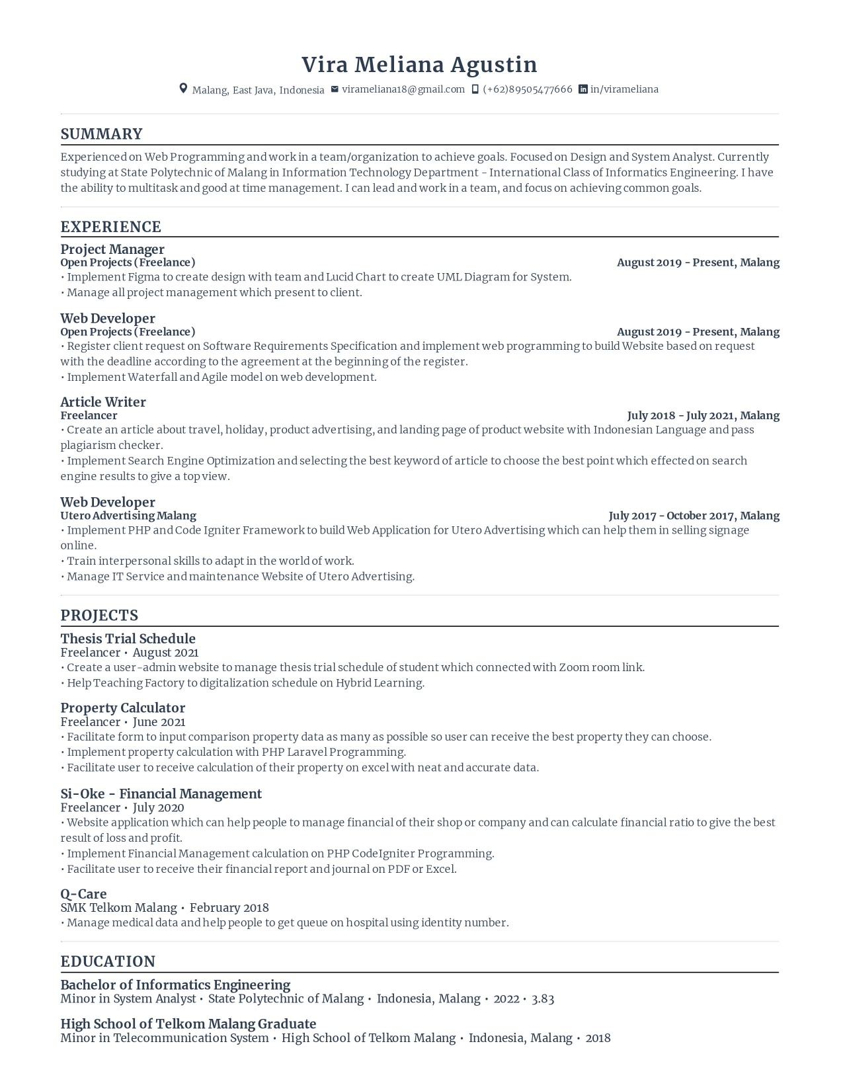

Figure 6. CV Vira Meliana Agustin

